 | Bansilal Ramnath Agarwal Charitable Trust's  Vishwakarma Institute of Information Technology  Department of  Artificial Intelligence and Data Science
Name: Siddhesh Dilip Khairnar
Class: SY | Division: B |  | Roll No: 272028
Semester: III |  | Academic Year: 2022-2023
Subject Name & Code: Data Structure, ADUA21202

Title of Assignment: Create a database using array of structures and perform following operations on it: i. Add record ii. Display Database iii. Search record (binary search) iv. Delete record

Assignment No.- 3

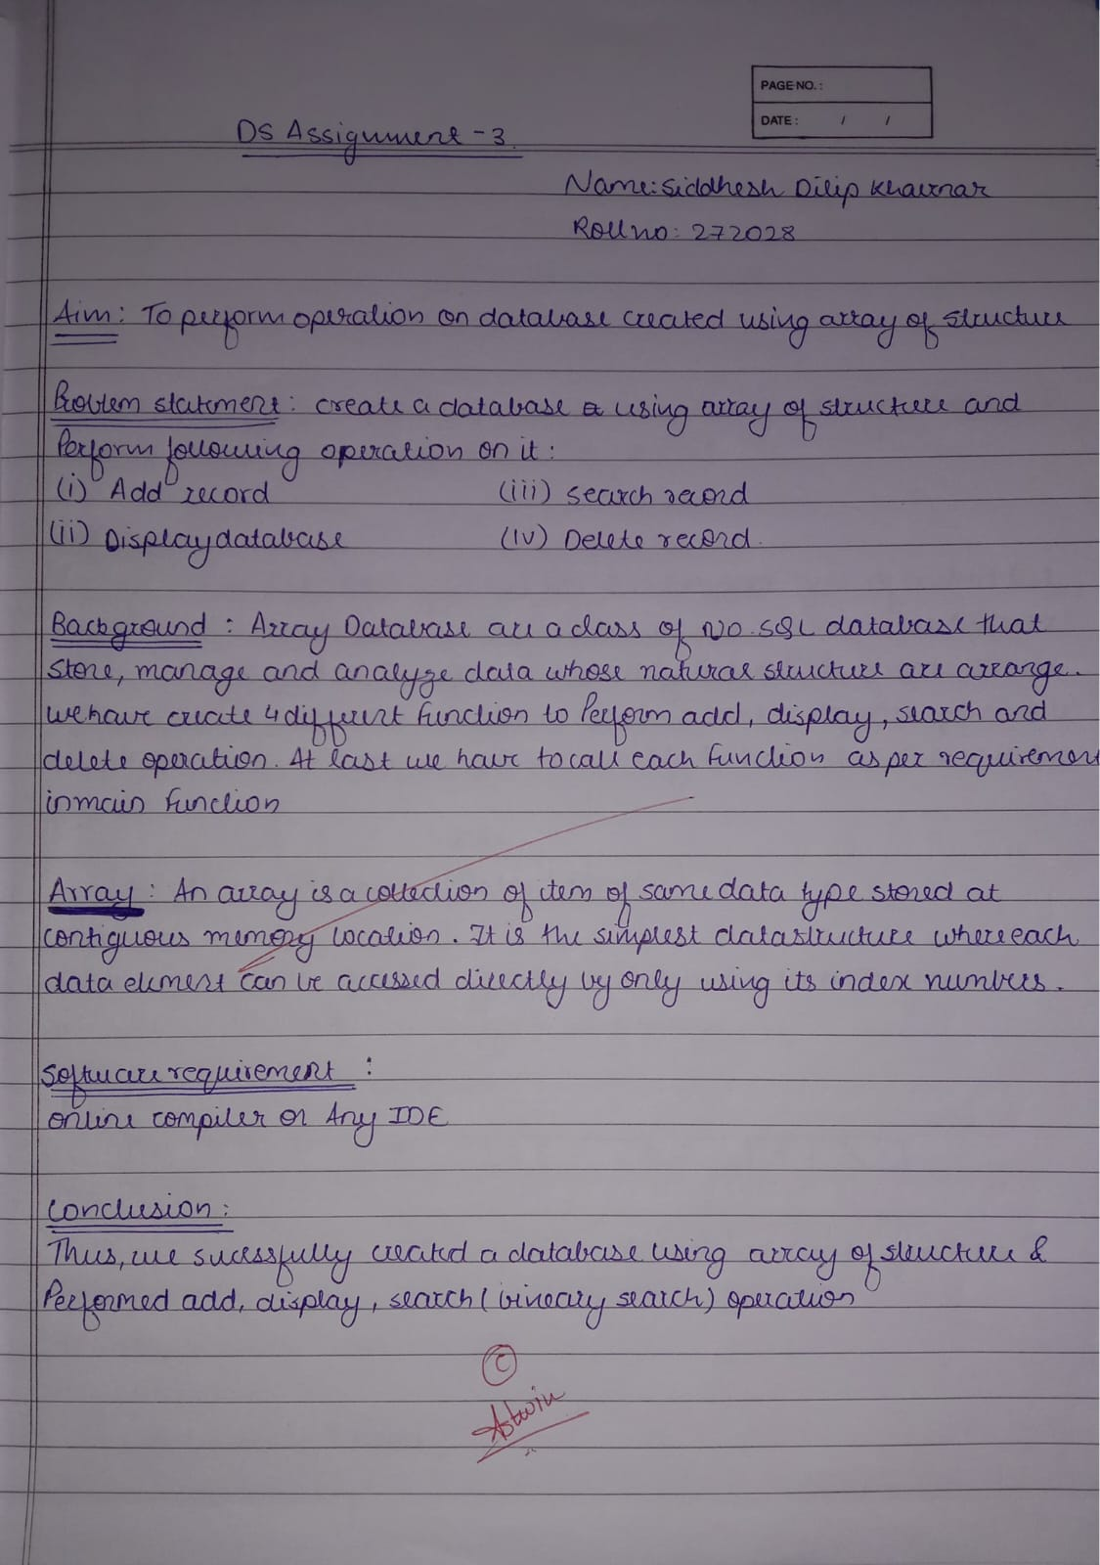

Program:

Output:

